**eg:Query the information of students.**

select * from student;

**Q1: Query the information and course scores of students whose grades in the "01" course are higher than those in the "02" course**

|  |
| --- |
| SELECT student.s_id, student.s_name, score.c_id AS course_01, score.s_score AS score_01, s2.c_id AS course_02, s2.s_score AS score_02  FROM student  JOIN score ON student.s_id = score.s_id AND score.c_id = '01'  JOIN score s2 ON student.s_id = s2.s_id AND s2.c_id = '02'  WHERE score.s_score > s2.s_score; |

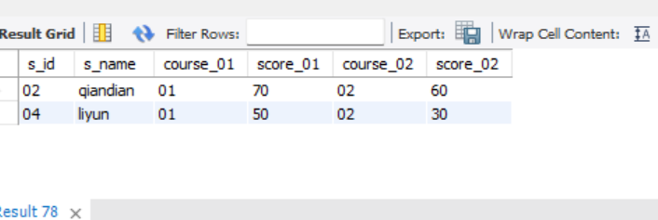

**Q2:** **Query the information and course scores of students whose grades in the "01" course are lower than those in the "02" course**

|  |
| --- |
| SELECT student.s_id, student.s_name, score.c_id AS course_01, score.s_score AS score_01, s2.c_id AS course_02, s2.s_score AS score_02  FROM student  JOIN score ON student.s_id = score.s_id AND score.c_id = '01'  JOIN score s2 ON student.s_id = s2.s_id AND s2.c_id = '02'  WHERE score.s_score < s2.s_score; |

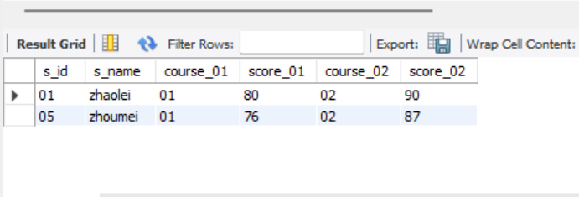

**Q3:** **Query the student number, student name and average score of students whose average score is greater than or equal to 60 points**

|  |
| --- |
| SELECT score.s_id, student.s_name, avg(score.s_score) AS AVERAGE  from score  join student on student.s_id = score.s_id  WHERE score.s_score >= 60  GROUP BY s_id |

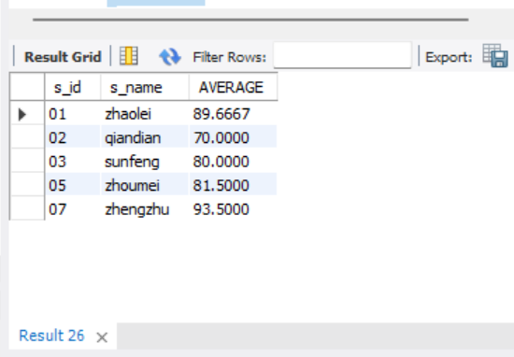

**Q4: Query the student number, name and average score of students whose average score is less than 60 points (including those with and without scores)**

|  |
| --- |
| SELECT score.s_id, student.s_name, avg(score.s_score) AS AVERAGE  from score  join student on student.s_id = score.s_id  WHERE score.s_score <= 60  GROUP BY s_id |

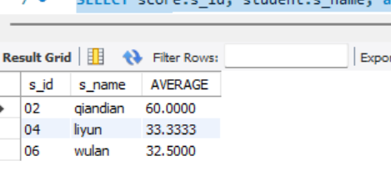

**Q5: Query the student number, student name, total number of courses selected, and total grades of all courses (including those without selected courses) of all students**

|  |
| --- |
| SELECT student.s_id, student.s_name, sum(score.c_id) AS COURSE, sum(score.s_score) AS SCORE  from score  JOIN student ON student.s_id = score.s_id  JOIN course ON course.c_id = score.c_id  GROUP BY s_id |

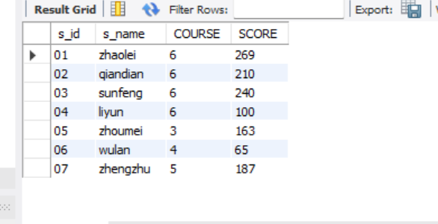

**Q6: Query the number of teachers with the surname "Li"**

|  |
| --- |
| SELECT t_id from teacher  where t_name like 'li%' |

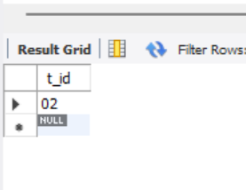

**Q7: Query the information of students who have studied with teacher "zhangsan"**

|  |
| --- |
| **SELECT student.s_name, teacher.t_name**  **FROM student**  **JOIN score ON score.s_id = score.s_id**  **JOIN course ON score.c_id = course.c_id**  **JOIN teacher ON course.t_id = teacher.t_id**  **WHERE teacher.t_name = 'zhangsan';** |

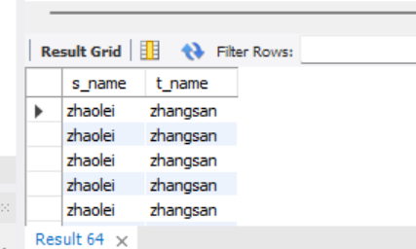

**Q8: Query the information of students who have not studied under teacher "zhangsan"**

|  |
| --- |
| SELECT student.s_name, teacher.t_name  FROM student  JOIN score ON student.s_id = score.s_id  JOIN course ON score.c_id = course.c_id  JOIN teacher ON course.t_id = teacher.t_id  WHERE teacher.t_name <> 'zhangsan'; |

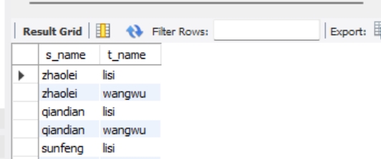

**Q9: Query the information of students who have studied the course numbered "01" and also studied the course numbered "02"**

|  |
| --- |
| SELECT student.s_name, course.c_id  from score  JOIN student on student.s_id = score.s_id  JOIN course on course.c_id = score.c_id  where course.c_id IN (01, 02) |

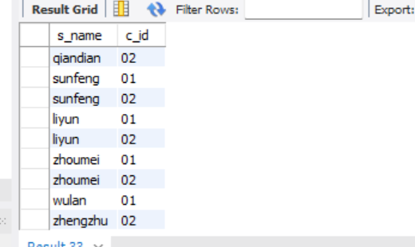

**Q10: Query the information of students who have studied the course numbered "01" but not the course numbered "02"**

|  |
| --- |
| SELECT student.s_name, course.c_id  FROM student  JOIN score ON student.s_id = score.s_id  JOIN course ON course.c_id = score.c_id  LEFT JOIN score AS score_2 ON student.s_id = score_2.s_id AND score_2.c_id = '02'  WHERE course.c_id = '01' AND score_2.s_id IS NULL; |

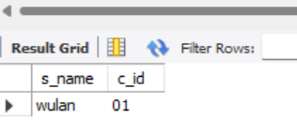

**Q11: Query information about students who have not completed all courses**

**Q12: Query the information of students who have at least one course that is the same as the student with student number "01"**

|  |
| --- |
| SELECT DISTINCT student.s_id, student.s_name  FROM student  JOIN score ON score.s_id = student.s_id  WHERE score.c_id IN (SELECT s2.c_id  FROM score s2  WHERE s2.s_id = '01')  AND student.s_id <> '01'; |

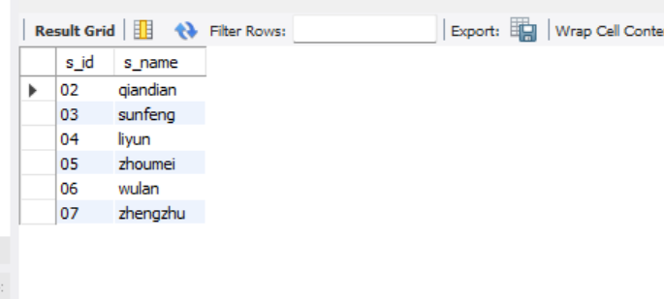

**Q13: Query the information of other students who are studying the same course as the student numbered "01"**

|  |
| --- |
| SELECT student.s_name, course.c_id  FROM score  JOIN student ON student.s_id = score.s_id  JOIN course ON course.c_id = score.c_id  WHERE score.c_id = '01'  AND score.s_id <> '01'; |

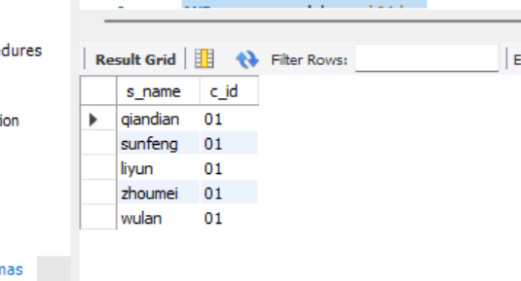

**Q14: Query the names of students who have not studied any course taught by "zhangsan"**

**Q15: Query the student ID number, name and average grade of students who failed two or more courses (Even if you did not take the exam, your score will be recorded as zero, so it should be considered a failure.)**

**Q16: Query the student information of "01" course whose score is less than 60 and sorted by score in descending order**

|  |
| --- |
| SELECT student.s_name, score.s_score  FROM score  JOIN student ON student.s_id = score.s_id  JOIN course ON course.c_id = score.c_id  WHERE course.c_id = '01' AND score.s_score < 60  ORDER BY score.s_score DESC; |

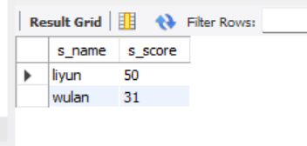

**Q17: Displays the grades for all students in all courses and the average grade by average grade from highest to lowest (Students who did not take the exam will have a score of 0)**

|  |
| --- |
| **SELECT student.s_id, student.s_name, course.c_id, IFNULL(score.s_score, 0) AS s_score,**  **IFNULL(AVG(score.s_score), 0) AS avg_score**  **FROM student**  **CROSS JOIN course**  **LEFT JOIN score ON student.s_id = score.s_id AND course.c_id = score.c_id**  **GROUP BY student.s_id, student.s_name, course.c_id**  **ORDER BY avg_score DESC;** |

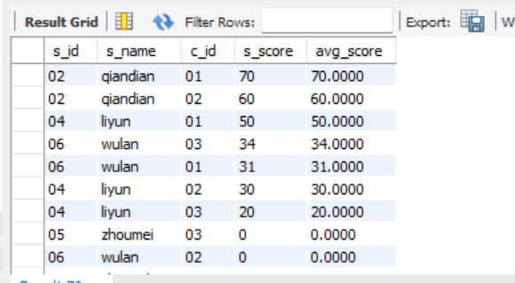

**Q18: Query the highest score, lowest score and average score of each subject: displayed in the following form: course ID, course name, highest score, lowest score, average score, passing rate, medium rate, good rate, excellent rate – passing is >=60 , medium is: 70-80, good is: 80-90, excellent is: >=90**

**Q19: Query the student information, Sort by the scores of each subject and display the ranking**

**Q20: Query students’ total scores and rank them**